PT Christian Implementation 1 Documentation

Goal
Monitor Traffic between Client and Server VMs
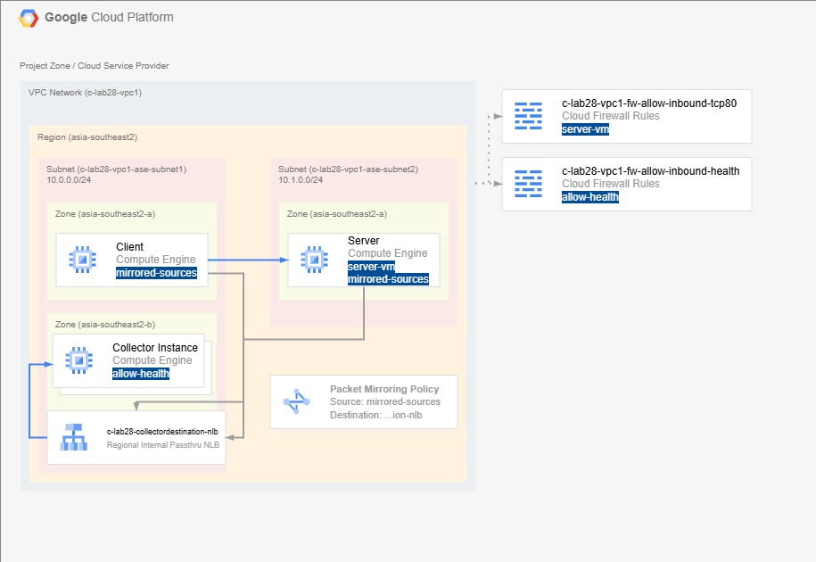

Step 0: Provision Environment

Created VPC Network
VPC Network name | c-lab28-vpc1
MTU | 1460
Subnet creation mode | Custom
Subnetworks | c-lab28-vpc1-ase2-subnet1  Region: asia-southeast2  IPv4 Range: 10.0.0.0/24  VPC Flow Logs: Disabled  Hybrid Subnets: Disabled  Private Google Access: Disabled  c-lab28-vpc1-ase2-subnet2  Region; asia-southeast2  IPv4 Range: 10.1.0.0/24  VPC Flow Logs: Disabled  Hybrid Subnets: Disabled  Private Google Access: Disabled
VPC Firewall Rules | c-lab28-vpc1-allow-custom  c-lab28-vpc1-allow-ssh
Dynamic Routing mode | Regional
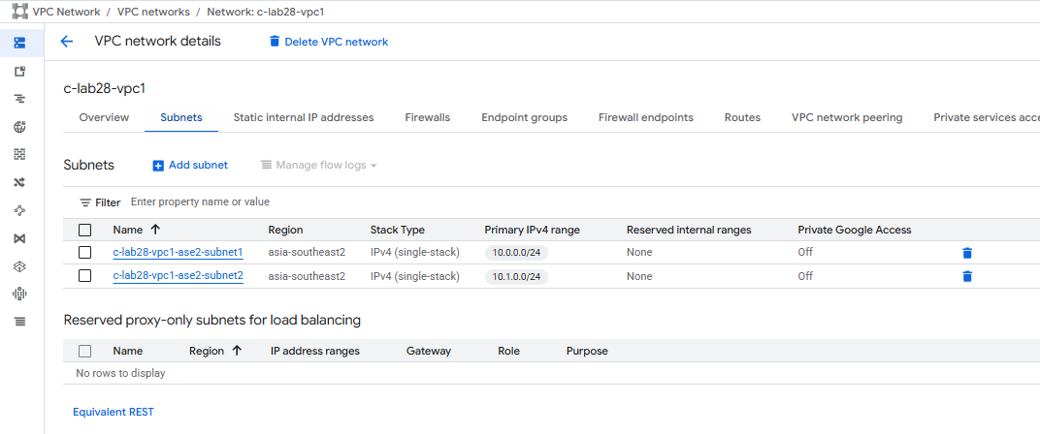

Created VPC Firewall Rule
VPC Firewall Rule name | c-lab28-vpc1-fw-allow-inbound-tcp80
VPC Network | c-lab28-vpc1
Logs | On
Priority | 300
Direction | Ingress
Action | Allow
Targets | Specified Target Tags
Target Tags | server-vm
Source Filter | IPv4 Ranges
Source IPv4 Ranges | 0.0.0.0/0
Protocols and Ports | TCP:80
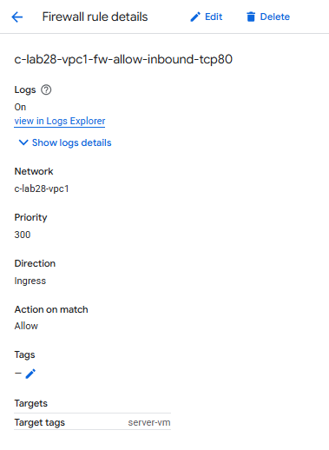

Created Virtual Machine (Client)
Virtual Machine name | c-lab28-client
Zone | asia-southeast2-a
Machine type | e2-micro
Boot Disk OS | Debian GNU/Linux 12 (bookworm)
Boot Disk type | Balancer persistent disk
Boot Disk size | 10 GB
Network Tags | client-vm
VPC Network | c-lab28-vpc1
Subnetwork | c-lab28-vpc1-ase2-subnet1
Primary Internal IPv4 Address | Ephemeral
External IPv4 Address | Ephemeral
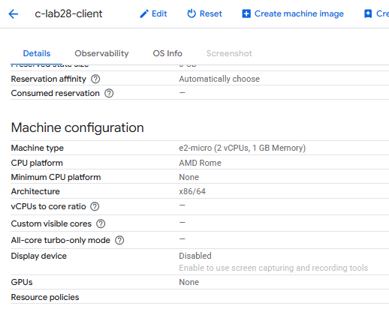

Created Virtual Machine (Server)
Virtual Machine name | c-lab28-server
Zone | asia-southeast2-a
Machine type | e2-micro
Boot Disk OS | Debian GNU/Linux 12 (bookworm)
Boot Disk type | Balancer persistent disk
Boot Disk size | 10 GB
Network Tags | server-vm
VPC Network | c-lab28-vpc1
Subnetwork | c-lab28-vpc1-ase2-subnet2
Primary Internal IPv4 Address | Ephemeral
External IPv4 Address | Ephemeral
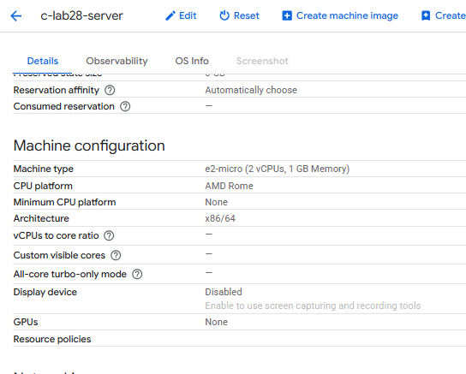

Configured Server VM
apt update
apt install apache2
echo “<h1>Welcome from $(hostname)</h1>” > /var/www/html/index.html
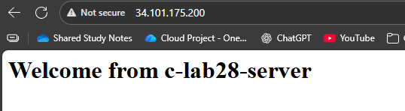

Test #1 – Test Connectivity between Client and Server
curl -X GET http://10.1.0.2
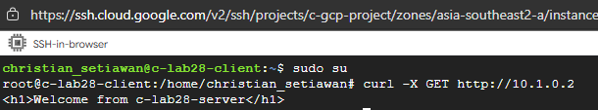
Connectivity established successfully!

Step 1: Create the Collector Destination

Theory
Packet Mirroring requires an instance group of Collector Instances.
Source: https://docs.cloud.google.com/vpc/docs/using-packet-mirroring#collector_instances

To enable Packet Mirroring, you must have an internal passthrough Network Load Balancer that can serve as a packet mirroring collector.
The internal passthrough Network Load Balancer must meet the following requirements:
- The internal passthrough Network Load Balancer's forwarding rule must have Packet Mirroring enabled when the rule is created. This status cannot be changed after the rule is created. You can use this forwarding rule to collect both IPv4 and IPv6 traffic.
- The internal passthrough Network Load Balancer is in the same region as the instances that you're mirroring.
- The internal passthrough Network Load Balancer's backend service must use a session affinity of NONE (5-tuple hash).
- The internal passthrough Network Load Balancer's backend service must have backend subsetting disabled.
If your collector instances are not set up to respond to the health check that you've configured with your backend service, the health check can fail. Packets can still be mirrored in this case.
Source: https://docs.cloud.google.com/vpc/docs/using-packet-mirroring#collector_instances

To prepare your VPC network for Packet Mirroring traffic, do the following:
- Ensure that collector instances in the load balancer's instance group can receive traffic from mirrored instances or from the IPv4 and IPv6 address ranges of mirrored instances.
For example, to let collector instances receive IPv4 traffic from any VM, create a firewall rule with a source IPv4 address range of 0.0.0.0/0. To let collector instances receive IPv6 traffic from any VM, create a firewall rule with a source IPv6 address range of ::/0. To prevent internet traffic from reaching the collector instances, assign only internal IPv4 and IPv6 addresses to them.
- Ensure that collector instances can receive traffic from the Google Cloud health checking systems.
For example, for IPv4 traffic, create a firewall rule that allows traffic to the collector instances from the IPv4 address ranges of 130.211.0.0/22 and 35.191.0.0/16. For IPv6 traffic, create a firewall rule that allows traffic to the collector instances from the IPv6 address range of 2600:2d00:1:b029::/64.
- If you want to test Packet Mirroring by manually sending egress traffic from one or more mirrored instances, create a firewall rule that allows SSH traffic to those instances.
For example, to allow SSH connections to your mirrored instances from all IPv4 and IPv6 addresses, allow ingress TCP traffic to port 22 from any source IPv4 and IPv6 address. If you want to only allow SSH connections that are initiated from a certain IPv4 or IPv6 address range, specify that IPv4 or IPv6 address range as a source range for the firewall rule. For more information about testing your internal passthrough Network Load Balancer, see Test load balancing.
Source: https://docs.cloud.google.com/vpc/docs/using-packet-mirroring#firewall_rules

Implementation

Created Instance Template
Instance Template name | c-lab28-collectorinstance-template
Location | Regional
Region | asia-southeast2
Machine Type | e2-micro
Boot Disk OS | Debian GNU/Linux 12 (bookworm)
Boot Disk type | Balanced persistent disk
Boot Disk size | 10 GB
Network Tags | allow-health
VPC Network | c-lab28-vpc1
Subnetwork | c-lab28-vpc1-ase2-subnet1
External IPv4 Address | None
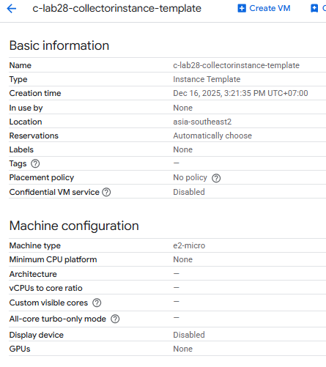

Created Virtual Machine (from the Instance Template)
Instance Template name | c-lab28-collectorinstance-template
Zone | asia-southeast2-a
Machine Type | e2-micro
Boot Disk OS | Debian GNU/Linux 12 (bookworm)
Boot Disk type | Balanced persistent disk
Boot Disk size | 10 GB
Network Tags | allow-health
VPC Network | c-lab28-vpc1
Subnetwork | c-lab28-vpc1-ase2-subnet1
External IPv4 Address | None
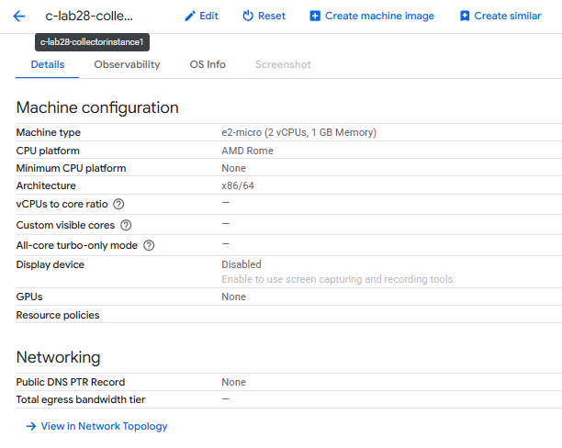

Created Unmanaged Instance Group
Unmanaged Instance Group name | c-lab28-collectorinstance-uig1
Zone | asia-southeast2-a
Instances | c-lab28-collectorinstance1
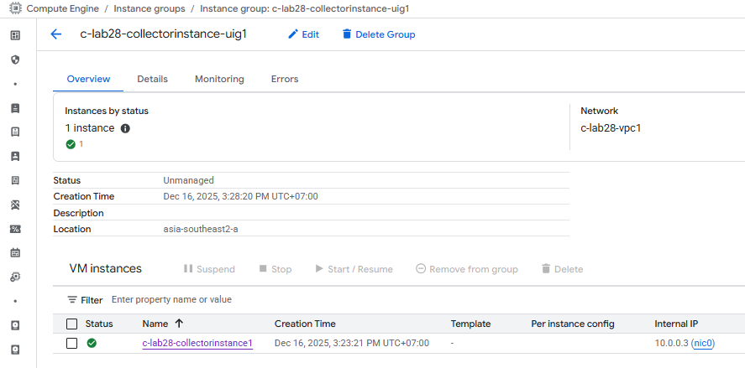

Created Internal Regional Passthrough Network Load Balancer
Load Balancer name | c-lab28-collectordestination-nlb
Region | asia-southeast2
VPC Network | c-lab28-vpc1
Backend Type | Instance Group
Protocol | TCP
Health Check | c-lab28-collectordestination-nlb  Protocol: TCP  Port: 80  Check Interval: 5 seconds  Timeout: 5 seconds  Healthy Threshold: 2  Unhealthy Threshold: 2
Backends | Instance Group: c-lab28-collectorinstance-uig1
Session Affinity | None
Frontend IP and Port | c-lab28-collectordestination-nlb-fe1  Protocol: TCP  IP Version: IPv4  Subnetwork: c-lab28-vpc1-ase2-subnet1  Internal IP Purpose: Non-shared  IP Address: Ephemeral (Automatic)  Ports: All  Global Access: Disable  Enable for Packet Mirroring: Enabled

Created VPC Firewall Rule
VPC Firewall Rule name | c-lab28-vpc1-fw-allow-inbound-health
VPC Network | c-lab28-vpc1
Logs | On
Priority | 200
Direction | Ingress
Action | Allow
Targets | Specified Target Tags
Target Tags | allow-health
Source Filter | IPv4 Ranges
Source IPv4 Ranges | 130.211.0.0/22  35.191.0.0/16  35.235.240.0/20
Protocols and Ports | TCP:80
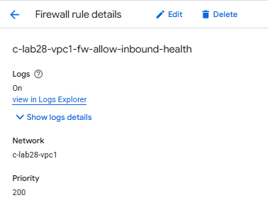

Configured Collector Instance to reply to Health Check

Created Cloud NAT Gateway
Cloud NAT Gateway name | c-lab28-cloudnat-gw1
Cloud Router name | c-lab28-cloudrouter1
NAT Type | Public
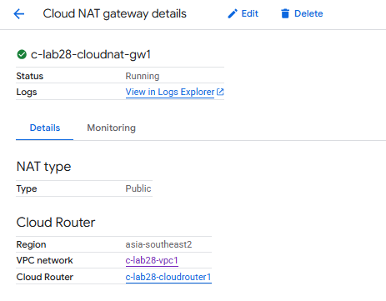

Run a Web Server that listens at Port 80
apt update
apt install apache2

Step 2: Create the Packet Mirroring Policy

Created Packet Mirroring Policy
Packet Mirroring Policy name | c-lab28-packetmirroring-policy1
Region | asia-southeast2
Priority | 1000
Enabled | Enabled
Source and Destination | On the same VPC Network
Mirrored Sources | Network Tag: mirrored-sources
Internal Passthrough NLB | c-lab28-collectordestination-nlb-fe1
Traffic to Mirror | Mirror all IPv4 traffic

Updated VMs
Added Network Tag “mirrored-sources” to Client VM and Server VM
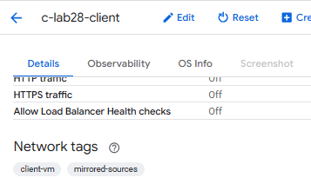
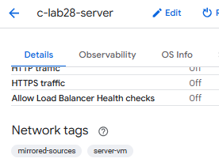

Step 3: Verify the Packet Mirroring Policy is working

Theory
To verify that your collector instances are correctly receiving mirrored traffic, you can use tcpdump.
- Connect to a collector instance.
- If the tcpdump command is not available, install it.
- Identify your network interface:
ip address
In the list of network interfaces, find the name that is associated with your collector instance's primary internal IPv4 address—for example, ens4.
- Start analyzing packets:
sudo tcpdump -i INTERFACE_NAME -f "host IP_ADDRESS"
Replace the following:
  - INTERFACE_NAME: the interface name that you identified in step 3.
  - IP_ADDRESS: the IPv4 address of a mirrored source VM.
- To run the test, send traffic from the mirrored source VM—for example, by sending an ICMP ping. In the output of tcpdump, verify that you can see the expected traffic.
Source: https://docs.cloud.google.com/vpc/docs/using-packet-mirroring#verify

Implementation

Log In to Mirrored Source Instance
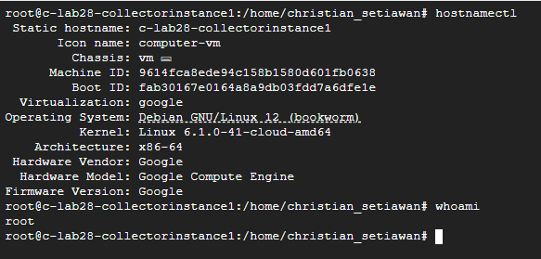

Executed the following command
Identify the Network Interface:
ip address
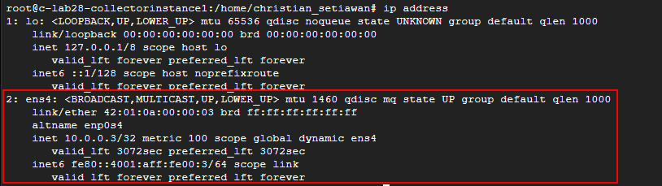
In our case, its ens4
tcpdump -i ens4 -f "host 10.0.0.2"
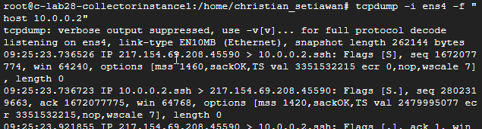
Example of Traffic Captured from Client to Server by Client VM
09:23:49.883130 IP 10.0.0.2.35322 > 10.1.0.2.http: Flags [.], ack 266, win 509, options [nop,nop,TS val 3218440765 ecr 950978835], length 0
Packet Mirroring works!

Example of Traffic Captured from Client to Server by Server VM
09:26:35.579655 IP 10.0.0.2.40086 > 10.1.0.2.http: Flags [.], ack 265, win 509, options [nop,nop,TS val 3218606462 ecr 951144531], length 0
Packet Mirroring works!
How to read:
- 09:26:35.579655
Time the Packet was captured

- 10.0.0.2.40086 > 10.1.0.2.http
Source: 10.0.0.2:40086
Destination: 10.1.0.2:http

- Flags [.]
ACK only (no SYN, no FIN, no data)

- ack 265
The Client acknowledges it receives 265 bytes from the Server

- win 509
The Client’s TCP receive window is 509 bytes at the moment

- [nop,nop,TS val 3218606462 ecr 951144531]
This shows the TCP Timestamps:
  - TS val : sender’s timestamp
  - TS ecr : echoed timestamp from the peer
User for RTT measurement and PAWS protection
- length 0
This shows the Payload Length (in this case it’s 0 because its just a TCP ACK)

Summary:
“This packet is a regular TCP ACK from a client at acknowledging data from a server at on port 80. It contains no HTTP data, just TCP‑level housekeeping.”
Source: Copilot
DONE

